Outcomes: understand what GIT is

Git removes need for copying files from class share and H drive to collaborate’

Git is like using a camera to take snapshot of files at certain points as backups

In gaming terms: checkpoint

Git exists to let you modify/improve code by saving instances so you can mess up and be fine

Git is used to collaborate allows people to work on all parts of project as same time

Git is a tool that protects you from yourself and others

Local workflow

We need to tell Git to start tracking our files:

1. Open file explorer
2. Create folder named practice in your h drive
3. Type cmd in the address bar
4. A command prompt should open to H:\practice

Gitinit creats repository(repo) in folder that command was run on. Hidden location where checkpoints are stored

Three main states: modified- files that are new or no new changes. Staged: current version of file. Committed- files safely stored by Git

We commit the box to storage and note what it contains

Until we commit work, there is no checkpoint

Git commit physically moves box of copied into long term storage, make sure to describe in case you need it

It does not move or remove files in your working directory

Today learning new stuff

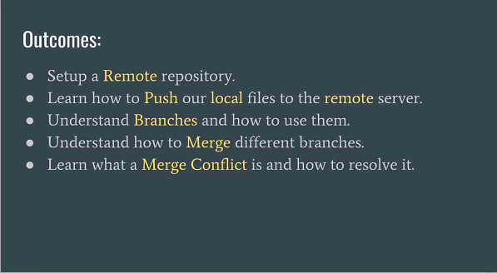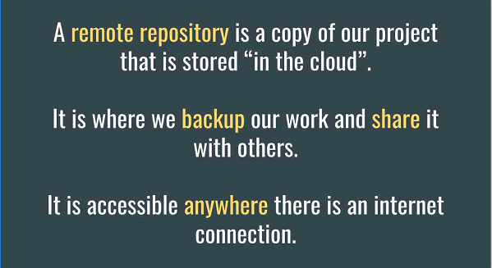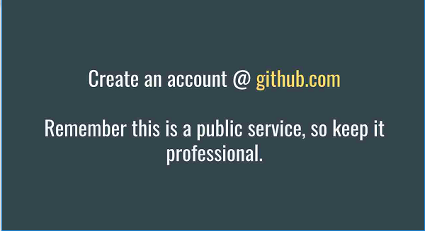

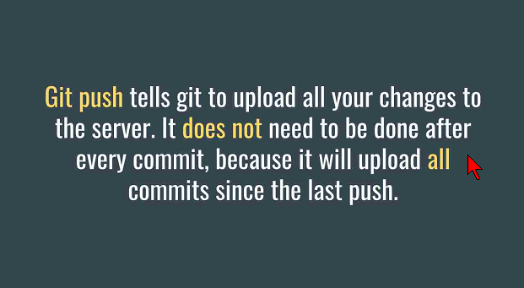

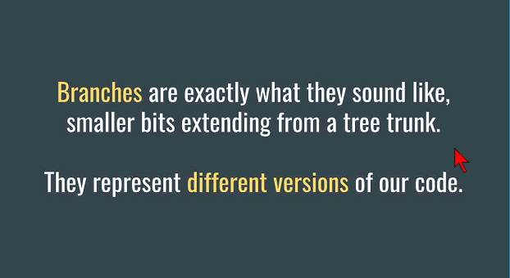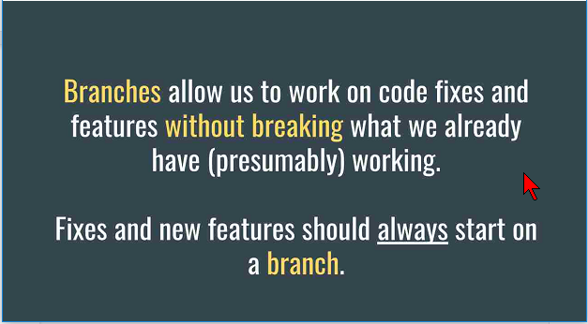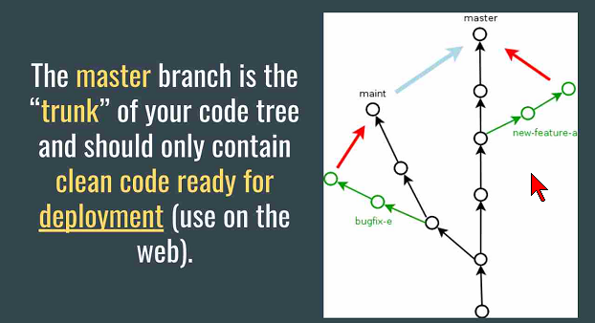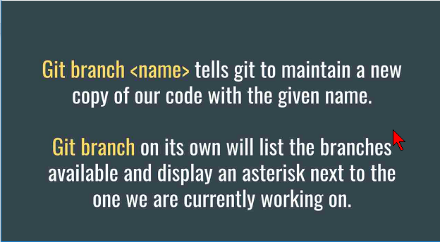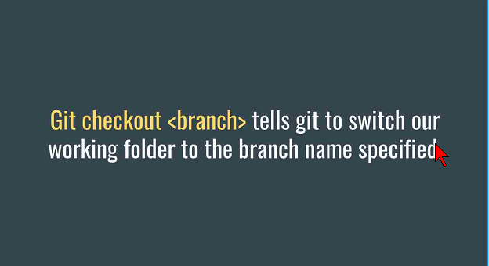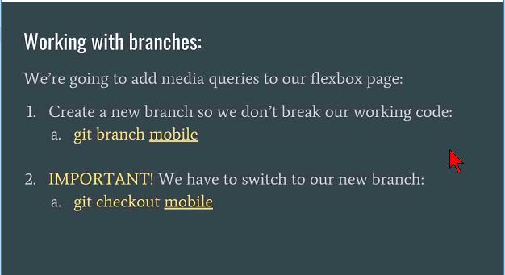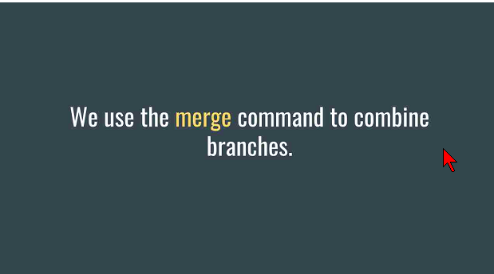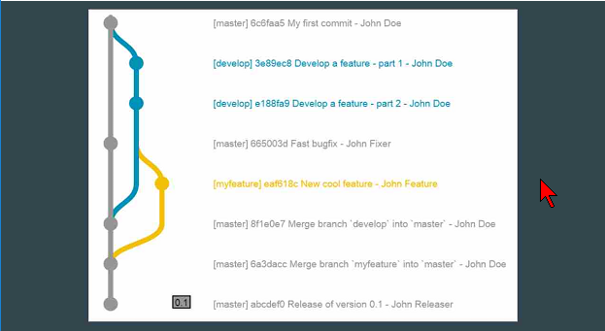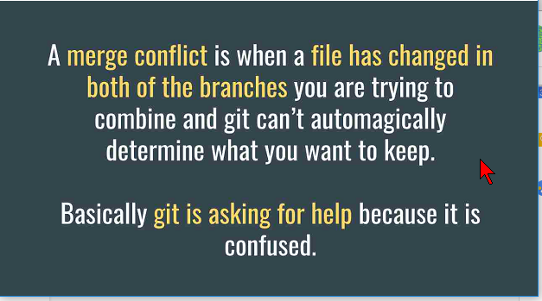

Today we learned about using branches in github. We first learned to create new branches and access them in the command prompt. Then we learned how to make changes within those branches to upload to the master branch. We also learned about conflicts with merging and how to resolve them. I would consider being a 4 on the scale of understanding with branches.